Project Report
on
“Cancer Detection using AI”
Submitted by
Aryan Jadav
Soham Bhosage
Ganraj Kendre
Varnan Dhondage

Under the guidance of
Prof. P. S. Patil

In partial fulfilment of
Diploma in Computer Engineering
[2022-2023]
At

DEPARTMENT OF COMPUTER ENGINEERING
MIT POLYTECHNIC
PUNE-411038
Affiliated to

MSBTE

ACKNOWLEDGEMENT

I am profoundly grateful to Prof. P. S. Patil of Computer Engineering Department for her expert guidance and continuous encouragement throughout to see that this project rights its target since its commencement to its completion. I would like to express my deepest appreciation towards Dr. Prof. R. S. Kale Principal, Prof. J. P. Khurpade HOD of Computer Department MAEER’S MIT POLYTECHNIC, Pune, whose invaluable guidance supported me in completing this project.
At last, I must express my sincere heartfelt gratitude to all the staff members of Computer Engineering Department who helped me directly or indirectly during this course of work.

NAME OF STUDENTS
Mr. Aryan Jadhav
Mr. Soham Bhosage
Mr. Ganraj Kendre
Mr. Varnan Dhondge
DIPLOMA IN COMPUTER ENGINEERING



ABSTRACT

Radiology is a broad subject that needs more knowledge and understanding of medical science to identify tumors accurately. The need for a tumor detection program, thus, overcomes the lack of qualified radiologists. Using magnetic resonance imaging, biomedical image processing makes it easier to detect and locate brain tumors. In this study, a segmentation and detection method for brain tumors was developed using images from the MRI sequence as an input image to identify the tumor area.

This process is difficult due to the wide variety of tumor tissues in the presence of different patients, and, in most cases, the similarity within normal tissues makes the task difficult. The main goal is to classify the brain in the presence of a brain tumor or a healthy brain.
The proposed system has been researched based on Berkeley’s wavelet transformation (BWT) and deep learning classifier to improve performance and simplify the process of medical image segmentation. Significant features are extracted from each segmented tissue using the gray-level-co-occurrence matrix (GLCM) method, followed by a feature optimization using a genetic algorithm. The innovative final result of the approach implemented was assessed based on accuracy, sensitivity, specificity, coefficient of dice, Jaccard’s coefficient, spatial overlap, AVME, and FoM.

TABLE OF CONTENTS

TABLE OF CONTENTS
Sr. No | CONTENTS | PAGE NO.
1 | INTRODUCTION OF PROJECT…………………………………………... | 1-10
 | 1.1 Motivation…………………………………………..................................... | 8
 | 1.2 Background …………………………………………................................... | 9
 | 1.3 Need of The Project…………………………………………....................... | 9
2 | LITERATURE SURVEY…………………………………………................. | 11-16
3 | SCOPE OF PROJECT…………………………………………...................... | 17-21
 | - Project objectives…………………………………………........................... | 17-19
 | 3.2 Project Features …………………………………………............................ | 20-21
 | 3.3 Project Cost (Overall Cost) …………………………………………........... | 21
4 | PROPOSED METHODOLOGY…………………………………………..... | 22-27
 | 4.1 System Architecture…………………………………………...................... | 22-23
 | 4.2 Detailed Description of Modules…………………………………………... | 24-27
5 | DETAILS DESIGN AND WORKING PROCESSES……………………… | 28-49
 | 5.1 Hardware Software Requirements…………………………………………. | 28
 | 5.2 DFD’s (0,1) level ………………………………………….......................... | 28-30
 | 5.3 Use Case Diagrams …………………………………………....................... | 30-31
 | 5.4 Activity diagram…………………………………………............................ | 32
 | 5.5 Sequence Diagram …………………………………………..................... | 33
 | 5.6 Timeline Chart…………………………………………............................... | 34
 | 5.7 Implementation………………………………………….............................. | 35-49
 | 5.7.1 Sample Code…………………………………………......................... | 35-38
 | 5.7.2 Types of Testing | 39-43
 | 5.7.3 Test Cases | 44-49
6 | RESULTS AND APPLICATION…………………………………………… | 50-53
 | 6.1 Result Screen Shot…………………………………………........................ | 50-52
 | 6.2 Application………………………………………….................................... | 52-53
7 | Conclusion and Future Scope…………………………………………........... | 54-55
 | References and Bibliography…………………………………………............ | 56-57
 | Certificates…………………………………………................................. | 58-65

LIST OF TABLES

TABLE NO. | TITLE | PAGE NO
Table No. 1 | Literature Survey…………………………………………................ | 13-15
Table No. 2 | Cost Table…………………………………………........................... | 21
Table No. 3 | Requirements | 28
Table No.4 | Test Cases | 44-49

LIST OF FIGURES

FIGURE NO. | TITLE | PAGE NO
Fig 4.1.1 | System Architecture | 22
Fig 4.1.2 | Model Loss | 23
Fig 4.1.3 | Model Accuracy | 23
Fig 5.2.1 | DFD Level 0 | 29
Fig 5.2.2 | DFD Level 1 | 30
Fig 5.3 | Use-case Diagram | 31
Fig 5.4.1 | Activity diagram for user interaction with the system | 32
Fig 5.5 | Sequence diagram | 33
Fig 5.6 | Timeline chart | 34

  - MOTIVATION

Cancer is a complex disease that can affect any part of the body. It occurs when abnormal cells divide and grow uncontrollably, invading and damaging nearby tissues and organs. If left undetected and untreated, cancer can spread to other parts of the body, leading to serious health complications and even death.

Early detection of cancer is critical for successful treatment and improved outcomes. However, cancer can be difficult to detect in its early stages because symptoms may not be noticeable until the disease has advanced. As a result, many cases of cancer are not diagnosed until later stages when the cancer has already spread.

Artificial intelligence (AI) can help in the early detection and prevention of cancer by analyzing patterns in patient data, such as medical records, imaging scans, and genetic information. AI algorithms can identify subtle changes in the data that may indicate the presence of cancer, even before symptoms appear.

For example, AI can be used to analyze mammography images for breast cancer screening. It can detect subtle changes in breast tissue that may indicate the presence of a tumor, even when it is too small to be detected by a human radiologist. AI can also be used to analyze genetic data to identify individuals who may be at higher risk for certain types of cancer, allowing for early intervention and preventive measures.

In addition to early detection, AI can also be used to help personalize cancer treatment based on individual patient characteristics. By analyzing large datasets of patient information, AI can identify patterns in treatment responses and outcomes, allowing for more tailored and effective treatment plans.

  - BACKGROUND

Artificial intelligence is a computer program or algorithm that uses past data to make future predictions. It teaches itself how to analyse and interpret data, which helps machine learning algorithms pick up on patterns that are not readily discernible to the human eye or brain. As these algorithms are exposed to more new data, their ability to learn and interpret the data improves. Researchers have also used deep learning, a type of machine learning, in cancer imaging applications. Deep learning refers to algorithms that classify information in ways much as the human brain does. Deep learning tools use “artificial neural networks” that mimic how our brain cells take in, process, and react to signals from the rest of our body. Research on AI for cancer imaging: Studies suggest that AI has the potential to improve the speed, accuracy, and reliability with which doctors answer those questions. But what scientists are most excited about is the potential for AI to go beyond what humans can currently do themselves. AI can “see” things that we humans can’t, and can find complex patterns and relationships between very different kinds of data.

  - NEED OF PROJECT

Attending lectures regularly directly affects the learning outcome of any student. AI can “see” things that we humans can’t, and can find complex patterns and relationships between very different kinds of data. AI can be more reliable when it comes to identifying if a tumor is cancerous or not. The accuracy of AI is reliable enough to be used in real life. This can help radiologists with the identification of tumors. This can also help the doctors, as AI can help to identify some specific features or symptoms of the tumor. This can further help doctors to learn about Cancer.

  - INTRODUCTION OF PROJECT

As a result, the radiology department has gained prominence in the study of brain tumors using imaging methods. Many studies have looked at the causes of brain tumors, but the results have not been conclusive. FCM helps to increase accuracy. Amato et al. structured PC-assisted recognition using mathematical morphological reconstruction (MMR) for the initial analysis of brain tumors. Test results show the high accuracy of the segmented images while significantly reducing the time of calculation. In classification of neural deep learning systems was proposed for the identification of brain tumors. Discrete wavelet transformation (DWT), excellent extraction method, and main component analysis (PCA) were applied to the classifier here, and performance evaluation was highly acceptable across all performance measurements.

In , a new classifier system was developed for brain tumor detection. The proposed system achieved 92.31% of accuracy. In , a method was suggested for classifying the brain MRI images using an advanced machine learning approach and brain structure analytics. To identify the separated brain regions, this technique provides greater accuracy and to find the ROI of the affected area. Researchers in [proposed a strategy to recognize MR brain tumors using a hybrid approach incorporating DWT transform for feature extraction, a genetic algorithm to reduce the number of features, and to support the classification of brain tumors by vector machine (SVM) . Specific segmentation concepts include region-based segmentation edge-based technique , and thresholding technique for the detection of cancer cells from normal cells. Common classification method is based on the Neural Network Classifier , SVM Classifier , and Decision Classifier . In , a brain tumor detection method was developed using the GMDSWS-MEC model. The result shows high accuracy and less time to detect tumors.

- IEEE Xplore, 2022: Active Contour Neural Network Identifying MRI Image Edge Computing Methods Deep Learning Bone Cancer Detection [1]
Author: Ediga Lingappa, Dr. L Rama Parvathy.
  - Bone cancer is a terrible disease that kills a lot of people. To identify cancer at an early stage, a system of detection and categorization is required provided. Early detection appears to be the sole element that improves the chances of a cancer patient's survival. One of the most difficult aspects of clinical diagnosis is cancer classification. This research discusses a system that employs techniques for detecting tumours and classifying cancer in images MR images of various patients using an artificial neural network algorithm. The purpose of this test is to find out if you have bone cancer, the proposed methodology employs edge recognition and segmentation methods are examples of computer vision algorithms, and preprocessing procedures such as filtering and grey conversion, detection, integration, and semantic segmentation.
  - Keywords— Artificial neural network Bone cancer, Detection Edge Recognition Semantic Segmentation.

- IEEE Xplore, 2022: Pancreatic Cancer Detection using Machine and Deep Learning Techniques [2]
Author: Anish Gupta, Apeksha Koul, Yogesh Kumar
  - Despite substantial research, pancreatic cancer has a terrible prognosis by having a survival rate of five years only. The premise behind early detection and better survival is that more people will benefit from a possible treatment. In general health care, machine and deep learning algorithms have shown to be a viable tool to classify or detect the risk of pancreatic cancer. As a result, in this work, we looked into various researchers' methods for diagnosing pancreatic cancer using machine and deep learning models. In addition, the report highlighted their achievements and the obstacles that remain in this sector. We incorporated our evaluation of the numerous strategies available to make some conclusions.
  - Keywords— Pancreatic Cancer; Artificial Intelligence; Machine Learning; Deep Learning.

- IEEE Xplore, 2020: Lung Cancer Detection Using Deep Learning Network: A Comparative Analysis [3]
Author: Susmita Das, Swanirbhar Majumder
  - Deep learning is an emergent and influential method which is used for feature learning and pattern recognition. We provide a comparison between Computer Aided Diagnosis scheme using Deep Learning Technique and traditional Computer Aided Diagnosis scheme in our paper. In this paper, we have compared several deep neural networks for recognition of pulmonary cancer. In our study, we find that Convolutional neural networks are used for pulmonary cancer detection in most of the cases, as compared to other algorithms in deep learning techniques. In conclusion, we address the few difficulties in the implementation of the systems for pulmonary cancer, then we summarise the advantages and disadvantages of the existing algorithms for diagnosis of pulmonary cancer.
  - Keywords— Pulmonary Cancer Detection, Lung Nodule, Deep Learning Network, Computer Aided Diagnosis scheme, Convolutional neural network.

- IEEE Xplore, 2020: Image Based Fractal Analysis for Detection of Cancer Cells [4]
Author: Jason Qin, Lindsay Pucket, Xin Qian
  - The key to treating cancer is early detection. In this study, we studied a fractal image analysis technique for cancer cell detection. Typical abnormalities in cancer cells include uncontrolled cell proliferation. Measurement of morphological complexity and study of figures with atypical shapes are possible with fractal analysis. Investigations were conducted using simulations of human breast cancer cells. We analyzed and compared changes in the fractal dimension between cancer cells and normal cells. According to our preliminary findings, the image-based fractal analysis approach can identify breast cancer cells. It has a great deal of potential to shed light on the morphological classification of tumor growth and might be used as a marker for early cancer identification and the effectiveness of cancer treatments.
  - Keywords: fractal dimension, cancer detection, image analysis

Sr. no | Paper title | Authors | Year of publication | Outcome
1. | Active Contour Neural Network Identifying MRI Image Edge Computing Methods Deep Learning Bone Cancer Detection | Ediga Lingappa, Dr. L Rama Parvathy. | 2022 | Bone cancer is a terrible disease that kills a lot of people. To identify cancer at an early stage, a system of detection and categorization is required provided. Early detection appears to be the sole element that improves the chances of a cancer patient's survival. One of the most difficult aspects of clinical diagnosis is cancer classification. This research discusses a system that employs techniques for detecting tumours and classifying cancer in images MR images of various patients using an artificial neural network algorithm. The purpose of this test is to find out if you have bone cancer, the proposed methodology employs edge recognition and segmentation methods are examples of computer vision algorithms, and preprocessing procedures such as filtering and grey conversion, detection, integration, and semantic segmentation.
2. | Pancreatic Cancer Detection using Machine and Deep Learning Techniques | Anish Gupta, Apeksha Koul, Yogesh Kumar | 2022 | Despite substantial research, pancreatic cancer has a terrible prognosis by having a survival rate of five years only. The premise behind early detection and better survival is that more people will benefit from a possible treatment. In general health care, machine and deep learning algorithms have shown to be a viable tool to classify or detect the risk of pancreatic cancer. As a result, in this work, we looked into various researchers' methods for diagnosing pancreatic cancer using machine and deep learning models. In addition, the report highlighted their achievements and the obstacles that remain in this sector. We incorporated our evaluation of the numerous strategies available to make some conclusions.
3. | Lung Cancer Detection Using Deep Learning Network: A Comparative Analysis | Susmita Das, Swanirbhar Majumder | 2020 | Deep learning is an emergent and influential method which is used for feature learning and pattern recognition. We provide a comparison between Computer Aided Diagnosis scheme using Deep Learning Technique and traditional Computer Aided Diagnosis scheme in our paper. In this paper, we have compared several deep neural networks for recognition of pulmonary cancer. In our study, we find that Convolutional neural networks are used for pulmonary cancer detection in most of the cases, as compared to other algorithms in deep learning techniques. In conclusion, we address the few difficulties in the implementation of the systems for pulmonary cancer, then we summarise the advantages and disadvantages of the existing algorithms for diagnosis of pulmonary cancer.
4. | Image Based Fractal Analysis for Detection of Cancer Cells | Jason Qin, Lindsay Pucket, Xin Qian | 2020 | The key to treating cancer is early detection. In this study, we studied a fractal image analysis technique for cancer cell detection. Typical abnormalities in cancer cells include uncontrolled cell proliferation. Measurement of morphological complexity and study of figures with atypical shapes are possible with fractal analysis. Investigations were conducted using simulations of human breast cancer cells. We analyzed and compared changes in the fractal dimension between cancer cells and normal cells. According to our preliminary findings, the image-based fractal analysis approach can identify breast cancer cells. It has a great deal of potential to shed light on the morphological classification of tumor growth and might be used as a marker for early cancer identification and the effectiveness of cancer treatments.
Table No. 1 Literature Survey

3.1 PROJECT OBJECTIVES
The primary objective of an AI algorithm for tumor detection is to accurately and efficiently identify the presence of tumors in medical images or reports. Some specific objectives of an AI algorithm for tumor detection may include:
- Early detection: Early detection of tumors is critical for improving patient outcomes, as early treatment can often be more effective and less invasive than treatment for advanced-stage tumors. AI algorithms for tumor detection can help detect tumors at an early stage, which can potentially save lives and improve patient outcomes.
- High accuracy: Accuracy is essential for tumor detection, as a misdiagnosis or false-positive result can lead to unnecessary treatment and potentially harmful consequences. AI algorithms can provide high accuracy in detecting tumors, reducing the likelihood of misdiagnosis and false positives.
- Automated detection: Automating the tumor detection process with AI algorithms can help reduce the workload of medical professionals and provide faster and more consistent tumor detection, potentially improving patient outcomes and reducing healthcare costs.
- Personalization: Personalized treatment plans based on patient-specific factors can lead to better treatment outcomes. AI algorithms can help identify unique tumor characteristics, providing personalized treatment plans based on individual patient factors.
- Real-time detection: Real-time detection of tumors during medical procedures can improve the accuracy and safety of these procedures. AI algorithms can provide rapid and real-time detection of tumors, potentially improving patient outcomes and reducing healthcare costs.
- Integration with clinical workflow: Integration with existing clinical workflows and information systems can help ensure that AI algorithms for tumor detection are seamlessly integrated into the healthcare system, improving the efficiency and effectiveness of healthcare delivery.
- Continual learning: Continual learning allows AI algorithms for tumor detection to continually improve their accuracy and performance over time, ensuring that they remain up-to-date and effective in detecting tumors.
AI is widely used in a lot of modern-day applications, these applications include the medical field. Here are some objectives of AI in the Medical Field:
- Diagnosis and treatment: AI can assist physicians in diagnosing and treating a wide range of medical conditions, from minor illnesses to life-threatening diseases. AI can analyze patient data, such as medical histories, symptoms, and test results, to help physicians make more accurate diagnoses and develop personalized treatment plans.
- Personalized medicine: AI can help doctors tailor treatments and therapies to the individual needs of patients, taking into account their genetics, lifestyle, and medical history. By analyzing large datasets of patient information, AI can help identify specific treatment options that are most likely to be effective for each patient.
- Predictive analytics: AI can help predict patient outcomes and disease progression, allowing doctors to make more informed decisions about treatment options. By analyzing patient data over time, AI can identify patterns and predict future health outcomes, potentially leading to more effective treatments and improved patient outcomes.
- Medical imaging analysis: AI algorithms can assist in the analysis of medical images, such as X-rays, MRI scans, and CT scans, to help identify abnormalities and make more accurate diagnoses. By analyzing large datasets of medical images, AI can identify patterns and abnormalities that may not be visible to the human eye, potentially leading to more accurate diagnoses and improved patient outcomes.
- Electronic health records: AI can help process and analyze electronic health records, allowing doctors to make more informed decisions and improve patient outcomes. By analyzing large datasets of patient information, AI can identify patterns and correlations that may be difficult for humans to detect, potentially leading to more effective treatments and improved patient outcomes.
- Drug discovery: AI can help speed up the drug discovery process, potentially leading to the development of new and more effective treatments for a range of medical conditions. By analyzing large datasets of molecular data, AI can identify potential drug candidates and predict their effectiveness, potentially reducing the time and cost associated with developing new drugs.
- Remote patient monitoring: AI can help remotely monitor patients, allowing doctors to detect changes in their health status and intervene before a medical emergency occurs. By analyzing data from wearable devices and other sensors, AI can identify changes in patient health status and alert doctors to potential problems, potentially leading to improved patient outcomes and reduced healthcare costs.
- Medical research: AI can help analyze vast amounts of medical data, such as clinical trials and medical literature, to uncover new insights and improve medical research. By analyzing large datasets of medical data, AI can identify patterns and correlations that may be difficult for humans to detect, potentially leading to new medical discoveries and improved patient outcomes.
- Medical education: AI can assist in medical education, by providing interactive simulations and personalized training for medical students, helping to improve their skills and knowledge. By providing personalized training and feedback, AI can help medical students develop the skills and knowledge they need to become effective physicians and improve patient outcomes.
- Widely accepted: Fingerprint recognition technology is widely accepted and used in various industries, including law enforcement, government, and finance, making it a trusted and established biometric technology.
Artificial Intelligence (AI) has gained significant attention in the medical field due to its potential to improve accuracy, efficiency, and patient outcomes. AI can be applied in various medical applications such as tumor detection, disease diagnosis, drug discovery, personalized medicine, and medical image analysis.

3.2 PROJECT FEATURES
- Feature extraction: Feature extraction is the process of identifying key features or patterns in medical images that can be used to differentiate between tumors and healthy tissue. AI algorithms use a variety of techniques to extract features from medical images, including texture analysis, edge detection, and shape analysis. Texture analysis, for example, involves analyzing the spatial distribution of pixel intensities in an image to identify areas of high and low contrast, which may indicate the presence of a tumor.
- Classification: Once features have been extracted from medical images, AI algorithms use machine learning techniques to classify them as either tumorous or non-tumorous. The algorithm is trained on a set of labeled images, where the presence or absence of a tumor is known. The algorithm learns to identify patterns in the features that are associated with the presence of a tumor, and can then apply this knowledge to new, unlabeled images.
- Segmentation: Segmentation is the process of identifying and separating the tumor from the surrounding healthy tissue in medical images. AI algorithms use a variety of techniques to perform segmentation, including thresholding, clustering, and region-growing. Thresholding involves setting a threshold value to differentiate between pixels that belong to the tumor and those that belong to healthy tissue. Clustering involves grouping pixels together based on their similarity, while region-growing involves expanding a seed region outward until it encompasses the entire tumor.
- Validation: Validation is a critical step in tumor detection algorithms, as it helps to ensure that the algorithm is accurate and reliable. Common validation techniques used in AI algorithms include cross-validation and performance metrics such as sensitivity, specificity, and accuracy. Cross-validation involves testing the algorithm on a subset of the data that was not used for training, to ensure that it can generalize to new data. Performance metrics, such as sensitivity (the percentage of true positive results) and specificity (the percentage of true negative results), provide a measure of the algorithm's accuracy.
- Integration with clinical workflows: To be useful in clinical practice, AI algorithms must be able to integrate with existing clinical workflows, such as electronic health records and picture archiving and communication systems (PACS). Integration allows clinicians to easily access and interpret the results of the algorithm, making it easier to incorporate into their decision-making processes.
- Continuous learning: AI algorithms can be designed to continuously learn from new data, in order to improve their accuracy and performance over time. This can be done using techniques such as transfer learning, where the algorithm is trained on a new set of data that is related to the original training data, or active learning, where the algorithm actively selects new data to learn from.
- Explainability: Explainability is a critical feature of AI algorithms in healthcare, as it helps to build trust among clinicians and patients. Explainability involves providing a clear and transparent explanation of how the algorithm arrived at its results, including the features it used to classify the image and any potential sources of error or bias. This can help clinicians make more informed decisions, and can help patients feel more confident in the accuracy and reliability of the algorithm.
.
Overall, AI algorithms for tumor detection offer significant benefits for the medical field. They are accurate, reliable, and convenient, and can be used in a wide range of applications to improve patient outcomes and advance medical research.

3.3 PROJECT COST
Sr. no. | Equipment | Cost
1. | Laptop | 45,500 RS
2. | Software | 20,000 RS
Table No. 2 Cost Table

4.1 SYSTEM ARCHITECTURE
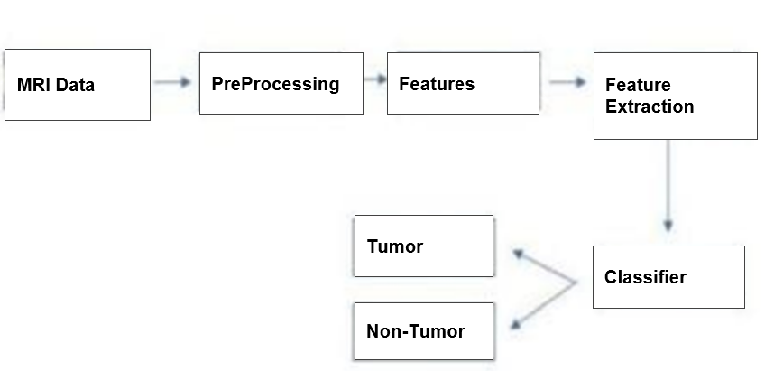
Fig 4.1.1 System Architecture
When using AI for cancer detection, the first step is to collect data in the form of MRI images or MRI reports. This data is then pre-processed, which can involve cleaning the data, normalizing it, and removing any noise or artifacts that may be present.

Once the data has been pre-processed, AI algorithms can be used to detect patterns or features in the data that may indicate the presence of a tumor. These patterns may be too subtle for a human observer to detect, but can be identified by the AI through machine learning techniques.

During the training process, the AI algorithm is fed a large dataset of MRI images or reports that have been labelled as either tumorous or non-tumorous. This labelled data allows the AI to learn the patterns and features that are associated with each class.

Once the AI has been trained, it can be used to classify new MRI images or reports as either tumorous or non-tumorous based on the patterns and features it has learned. This classification can be done using a classifier, which is a type of algorithm that takes in the detected features and makes a prediction about the class of the data.
Overall, the use of AI for cancer detection has the potential to greatly improve the accuracy and efficiency of cancer diagnosis, allowing for earlier detection and more effective treatment.
Fig 4.1.2 Model Loss
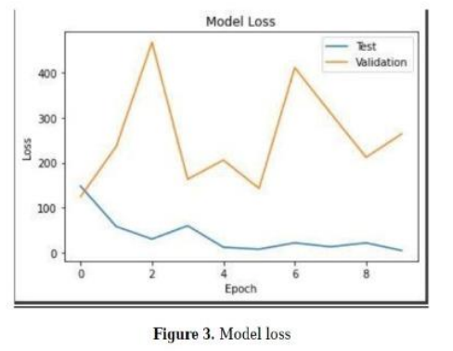
Fig 4.1.3 Model accuracy
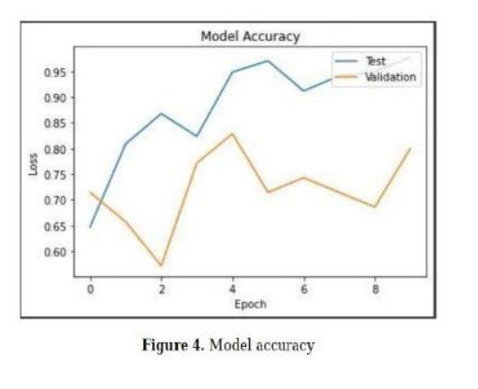
Python is being used for this project. Python is a widely used interpreted, interactive, object-oriented, and high-level computer language. Python is a garbage-collected and dynamically typed computer language. Guido van Rossum designed it between 1985 and 1990. Python source code, like Perl, is accessible under the GNU General Public License. (GPL).
Python covers a variety of programming paradigms, including procedural, object-oriented, and functional languages. Python's design ideology prioritises code readability by employing significant indentation.
4.2 DETAILED DESCRIPTION OF MODULES
4.2.1 WORKING OF MODULE:
After the user enters all the details of the tumor, the data is preprocessed and fed into the AI algorithm. The algorithm is divided into a training set and a testing set to train and evaluate the model's performance. In the training set, both input and output are provided to the AI module, while in the testing set, only input is provided to check the accuracy of the data model.
Before training the model, it is important to preprocess the data. One important step is to properly scale the data, which makes it easier for the algorithm to predict the output. In Python, the 'sklearn' library provides various methods to scale the data.
Once the data is preprocessed and scaled, three different algorithms can be used for tumor classification: Linear Regression, Decision Tree Classifier, and Random Forest Classifier.
- Linear Regression is a statistical method that uses a linear approach to model the relationship between the input variables and the output variable. It is used to predict a continuous numerical output, and it works best when there is a linear relationship between the input and output variables.
- Decision Tree Classifier is a tree-based model that recursively partitions the input space into a set of decision rules based on the most informative feature at each node. It works well for both numerical and categorical data, and it is useful for problems where the input features have nonlinear relationships with the output variable.
- Random Forest Classifier is an ensemble learning algorithm that combines multiple decision trees to improve the accuracy of the classification. It works by randomly selecting subsets of the input features and data to train multiple decision trees. The final output is determined by aggregating the outputs of all the individual decision trees.
Overall, by using these algorithms, the AI model can accurately classify tumors and help in early detection and prevention of cancerous tumors from growing further.

4.2.2 LINEAR REGRESSION:
Logistic regression is a commonly used supervised learning algorithm in tumor classification. It is a statistical method that models the probability of a binary outcome based on input features. In tumor classification, logistic regression can be used to predict whether a tumor is benign or malignant based on features such as tumor size, shape, and texture.
The logistic regression model works by taking the input features and mapping them to a continuous output value between 0 and 1 using a logistic function, also known as a sigmoid function. The output can then be interpreted as the probability of the tumor being malignant. The decision boundary between malignant and benign tumors is set at a threshold value, typically 0.5. If the predicted probability is greater than the threshold, the tumor is classified as malignant; otherwise, it is classified as benign.
The logistic regression model is trained using a labeled dataset of tumor samples. The weights of the model are optimized to minimize the error between the predicted output and the true label using an optimization algorithm such as gradient descent. The model is evaluated using various performance metrics such as accuracy, precision, recall, and F1 score to assess its effectiveness in tumor classification.
Logistic regression is a simple and interpretable algorithm that can handle both continuous and categorical input features. However, it may not perform well if the relationship between the input features and the outcome is complex or nonlinear. In such cases, more complex algorithms such as decision tree classifiers and random forest classifiers may be more appropriate.

4.2.3 DECISION TREE CLASSIFIER:
The decision tree classifier is a tree-based machine learning algorithm that is commonly used in tumor classification. It is a supervised learning algorithm that recursively partitions the input space into a set of decision rules that are learned from the training data.
The decision tree model takes input features such as the size, shape, and texture of a tumor and creates a binary tree structure where each internal node corresponds to a decision rule based on a specific feature. The model recursively partitions the data based on the most informative feature at each node, and the final leaf nodes of the tree correspond to the predicted output, indicating whether the tumor is malignant or benign.
The decision tree model is trained using a labeled dataset of tumor samples. The structure of the tree is optimized to minimize the error between the predicted output and the true label using various methods such as information gain or Gini impurity. The model is evaluated using various performance metrics such as accuracy, precision, recall, and F1 score to assess its effectiveness in tumor classification.
One advantage of the decision tree model is that it can handle both continuous and categorical input features, and it is also interpretable as the decision rules learned by the model can be easily visualized. However, decision trees are prone to overfitting, which means they can fit the training data too closely and may not generalize well to new data. To address this issue, ensemble methods such as random forest classifiers are commonly used in tumor classification.

4.2.4 RANDOM FOREST CLASSIFIER:
Random forest classifier is an extension of the decision tree algorithm and can provide higher accuracy in tumor classification. Random forests use an ensemble of decision trees to improve the performance of the model. Each tree in the forest is trained on a different subset of the data and a different set of features, thus reducing the risk of overfitting the model.
In a random forest classifier, the input features such as the size, shape, and texture of a tumor are used to train multiple decision trees on different subsets of the training data. Each decision tree independently produces a binary output, indicating whether the tumor is malignant or benign. The final output of the random forest model is then determined by aggregating the outputs of all the individual decision trees.
The process of aggregating the outputs can be done by either taking the majority vote of the outputs or by taking the average of the outputs. The final output of the random forest model is then the one with the highest number of votes or the average of the outputs. This method of combining the outputs of multiple decision trees helps to improve the accuracy and reduce the risk of overfitting.
The random forest model is trained using a dataset of labeled tumor samples, and the structure of the decision trees and the subsets of the training data are optimized to minimize the error between the predicted output and the true label. This optimization process is done using various techniques such as the Gini index or entropy to determine the best split at each node of the decision tree. The final structure of the decision trees is then determined by combining the results of all the individual trees in the forest.

5.1 HARDWARE & SOFTWARE REQUIREMENTS
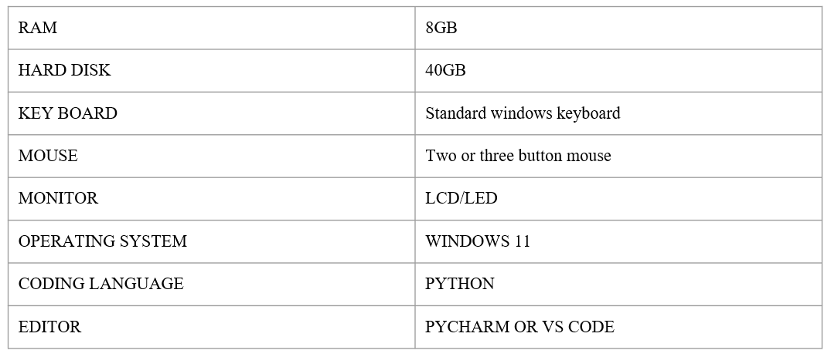
table 5.1.1 Requirements

5.2 DATA FLOW DIAGRAM (DFD’S)
Data flow diagrams (DFDs) are visual representations that illustrate the flow of information in a system. They are used to model the flow of data between various entities and processes within a system. DFDs are commonly used in software engineering and business process modelling to help understand, document, and analyse a system's functionality.
DFDs are usually depicted using standardized symbols and notation, such as circles for entities, rectangles for processes, arrows for data flows, and double-lined squares for data stores. They can be used to represent a high-level overview of a system, or to drill down into more detailed views of specific processes or data flows.
DFDs can be used for a variety of purposes, including:
- Identifying data requirements for a system
- Identifying potential bottlenecks or inefficiencies in a system
- Describing system functionality to stakeholders
- Identifying opportunities for improvement in a system's design or implementation.
Overall, data flow diagrams are a useful tool for modelling and understanding the flow of data within a system, and can help improve system design, implementation, and performance. DFD may be further partitioned into different levels to show detailed information flow. For example: level 0, level 1, etc.

5.2.1 DFD LEVEL 0
A level 0 data flow diagram (DFD) provides a high-level view of the system or process being analysed, and shows the main entities and processes involved, as well as the data flows between them. In a level 0 DFD, the entire system is represented as a single process box, with all the external entities and data stores connected to it.
The purpose of a level 0 DFD is to provide a broad overview of the system, and to identify the major inputs, processes, and outputs that make up the system. It serves as a starting point for more detailed analysis and modelling, and helps stakeholders understand the system's overall structure and functionality.
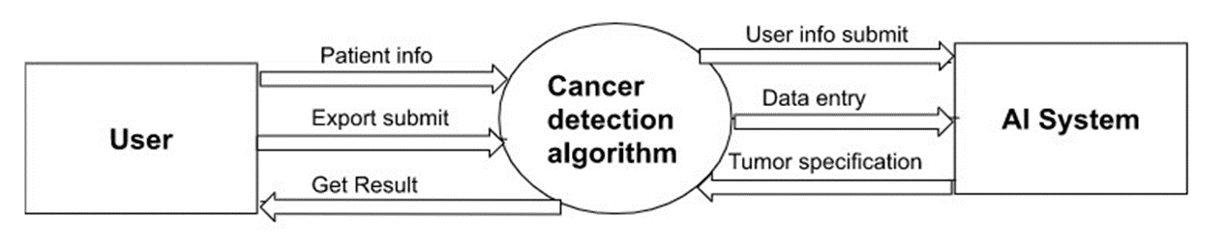
Fig 5.2.1 DFD Level 0

5.2.2 DFD LEVEL 1
A level 1 data flow diagram (DFD) is a more detailed view of the system than a level 0 DFD, and shows the main processes, data flows, and data stores that make up the system. In a level 1 DFD, the system is decomposed into several subprocesses, each with its own process box and associated data flows.
The purpose of a level 1 DFD is to provide a more detailed understanding of the system, and to identify the subprocesses and data flows that make up the overall system. It helps stakeholders understand how the system works at a more detailed level, and can be used to identify areas for improvement in the system's design or implementation.
In a level 1 DFD, the main process from the level 0 DFD is decomposed into several subprocesses, each represented by its own process box. These subprocesses may be labelled with names that describe their specific function within the overall system.
This gives a more detailed view of how our project works and its actual flow.
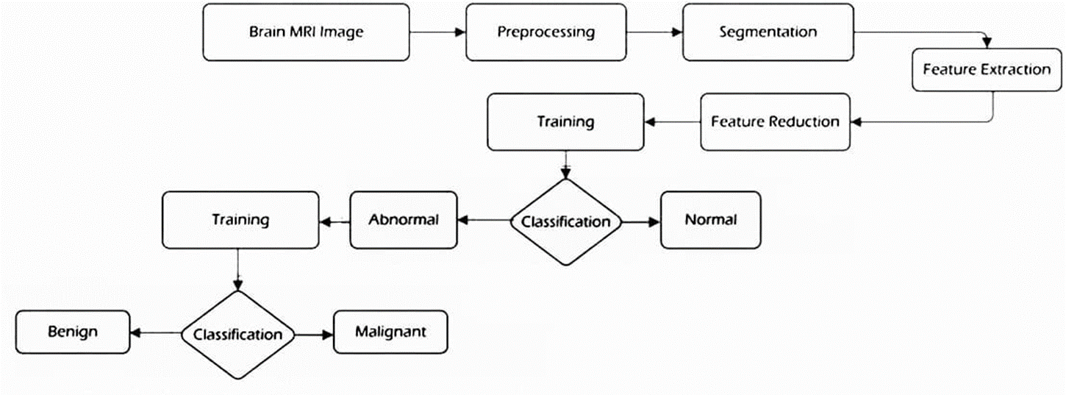
Fig 5.2.2 DFD Level 1

5.3 USE-CASE DIAGRAM
A use case diagram is a type of behavioural diagram in the Unified Modelling Language (UML) that describes the functionality of a system from the user's point of view. It is a graphical representation of the interactions between the users (actors) and the system, and the different use cases or scenarios in which they can be involved.
A use case diagram typically consists of actors, use cases, and relationships between them. Actors are external entities that interact with the system, such as users, customers, or other systems. Use cases represent the specific tasks or actions that the system can perform to meet the needs of the actors. The relationships between actors and use cases describe how the actors interact with the system to accomplish their tasks.
The main benefits of use case diagrams include:
- Providing a clear, high-level view of the system's functionality from the user's perspective
- Helping to identify the different actors and use cases involved in the system
- Providing a basis for further analysis and design of the system
- Supporting communication and collaboration between stakeholders, such as developers, designers, and users.
- 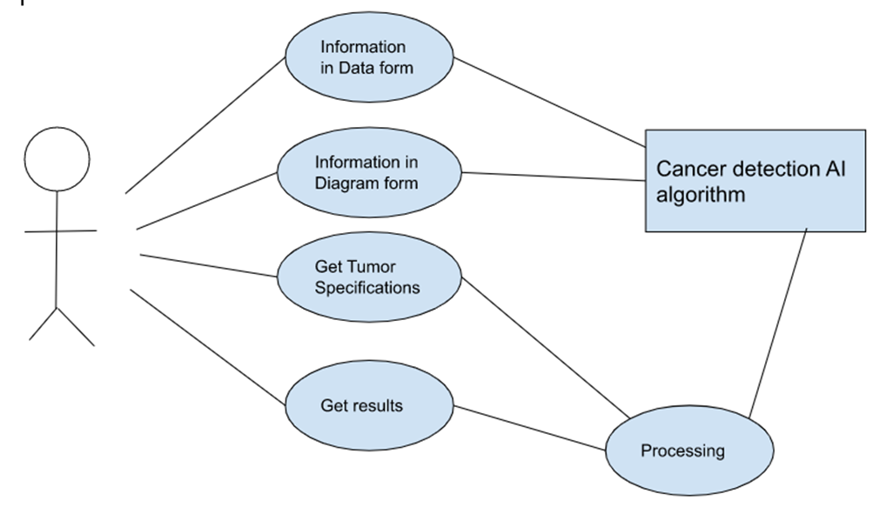
Fig 5.3 Use-case Diagram
5.4 ACTIVITY DIAGRAM
An activity diagram is a type of behaviour diagram in the Unified Modelling Language (UML) that shows the flow of activities within a system or process. It is used to model the dynamic aspects of a system or process, and to show the sequence of activities that take place.
Activity diagrams are similar to flowcharts, but are more powerful and flexible. They allow for more complex behaviours to be modelled, including conditional branching, parallel activities, and loops.
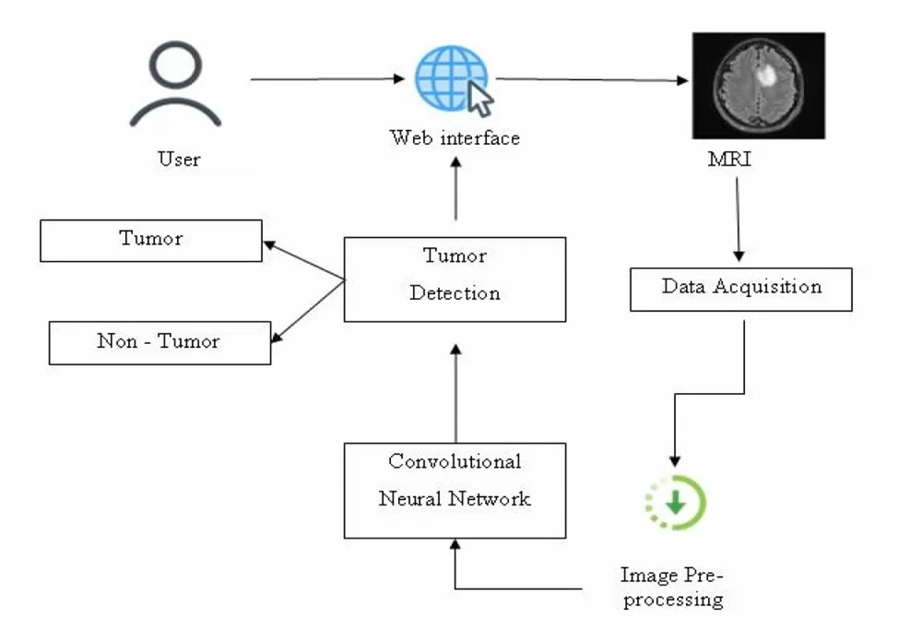
Fig 5.4 Activity Diagram for user interaction with the system

5.5 SEQUENCE DIAGRAM
Sequence diagrams can be used to model a wide range of systems and processes, from software systems to business processes. They are particularly useful for modelling the interactions between objects or components in a system, and for identifying areas for optimization and improvement.
Some common uses of sequence diagrams include:
1. Designing and testing software systems
2. Identifying performance bottlenecks in systems
3. Communicating requirements and design decisions to stakeholders

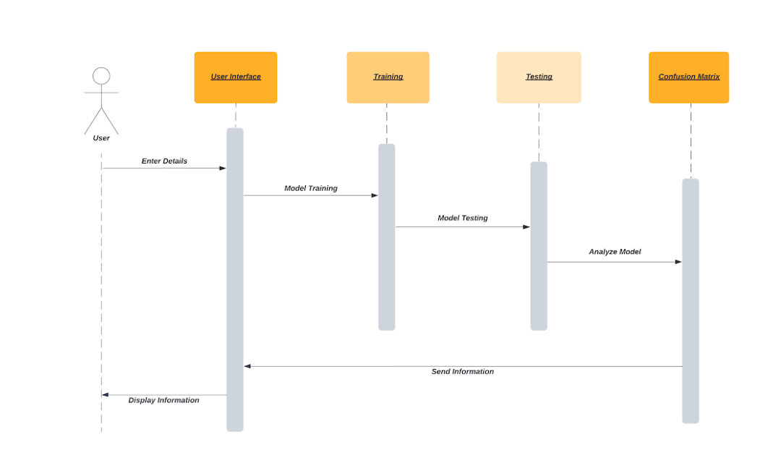
Fig 5.5 Sequence Diagram

5.6 TIMELINE CHART
A timeline chart is a graphical representation of events, activities, or milestones over time. It is commonly used in project management, history, and other fields where it is important to understand the sequence and duration of events.
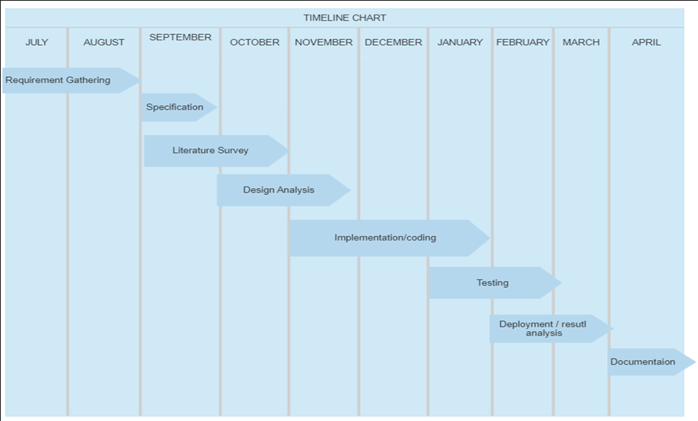
Timeline charts can be created using a variety of tools, including spreadsheet software, project management software, and specialized timeline software. They are a useful tool for visualizing and communicating the sequence and duration of events over time.
Fig 5.6 Timeline Chart (Gannt Chart)

5.7 IMPLEMENTATION
5.7.1 SAMPLE CODE
#Importing
import pandas as pd
import numpy as np
import matplotlib.pyplot as plt
import seaborn as sns

df = pd.read_csv('cancer.csv')
df.head(5)
df.isnull()
df=df.dropna()
df.shape
df['diagnosis'].value_counts()

from sklearn.preprocessing import LabelEncoder
labelencoder_Y = LabelEncoder()
df.iloc[:,0] = labelencoder_Y.fit_transform(df.iloc[:,0].values)
sns.pairplot(df.iloc[:,0:5], hue='diagnosis')
#Actual Implementation
#Split into data sets of independent(X) and dependent(Y) data sets
x = df.iloc[:,1:31].values #features
y = df.iloc[:,0].values #cancer or not

#Scale data(features)
from sklearn.preprocessing import StandardScaler
sc = StandardScaler()
x_train = sc.fit_transform(x_train)
x_test = sc.fit_transform(x_test)

#function for the model
#Logistic regresion
def models1(x_train, y_train):
from sklearn.linear_model import LogisticRegression
log = LogisticRegression(random_state=0)
log.fit(x_train, y_train)
return log

# Desicion Tree
def models2(x_train,y_train):
from sklearn.tree import DecisionTreeClassifier
tree = DecisionTreeClassifier(criterion='entropy',random_state=0)
tree.fit(x_train, y_train)

print('Decision Tree Accuracy:',tree.score(x_train,y_train))
return tree

# Desicion Tree
def models3(x_train,y_train):
from sklearn.ensemble import RandomForestClassifier
forest = RandomForestClassifier(n_estimators= 10, criterion='entropy',random_state = 0)
forest.fit(x_train,y_train)
print('Random Forest Classifier:', forest.score(x_train,y_train))
return forest

model1 = models1(x_train, y_train)
model2 = models2(x_train, y_train)
model3 = models3(x_train, y_train)

#Testing a model
from sklearn.metrics import confusion_matrix
cm = confusion_matrix(y_test, model1.predict(x_test))
TP = cm[0][0]
TN = cm[1][1]
FN = cm[1][0]
FP = cm[0][1]
print(cm)
print("Testing Accuracy is ",(TP + TN)/(TP + TN + FP + FN))
from sklearn.metrics import confusion_matrix
cm = confusion_matrix(y_test, model2.predict(x_test))

TP = cm[0][0]
TN = cm[1][1]
FN = cm[1][0]
FP = cm[0][1]
print(cm)
print("Testing Accuracy is ",(TP + TN)/(TP + TN + FP + FN))
from sklearn.metrics import confusion_matrix
cm = confusion_matrix(y_test, model3.predict(x_test))

TP = cm[0][0]
TN = cm[1][1]
FN = cm[1][0]
FP = cm[0][1]
print(cm)
print("Testing Accuracy is ",(TP + TN)/(TP + TN + FP + FN))

5.7.2 TYPES OF TESTING
Software testing is a process of evaluating a software application or system to identify any defects, errors, or bugs that may impact its quality, reliability, or performance. The primary objective of software testing is to ensure that the software meets the desired quality, functionality, and performance requirements before it is released to end-users.
The testing process involves executing the software application or system with a predefined set of test cases to verify that it works correctly, meets the specified requirements, and is free from defects or errors. The testing process is typically performed by a dedicated team of testers who are responsible for identifying any issues that may impact the software's usability, reliability, or performance.

Unit Testing:
Unit testing is a type of software testing in which individual components or units of a software application are tested in isolation to ensure that they function correctly and meet the specified requirements. The goal of unit testing is to identify any defects, errors, or bugs in the code and fix them before they can cause issues in the rest of the software system.
Unit testing has several benefits, including:
- Improved code quality: Unit testing helps to identify defects and errors early in the development cycle, allowing developers to fix them before they can cause issues in the rest of the system. This leads to improved code quality and reduces the time and cost required to fix defects later in the development cycle.
- Faster development: Unit testing allows developers to catch defects early, reducing the time required to fix them and improving the overall development speed.
- Increased confidence: Unit testing provides developers with increased confidence in their code, as they know that it has been thoroughly tested and is less likely to contain defects or errors.
- Easier maintenance: Unit tests serve as a form of documentation for the code, making it easier to understand and maintain over time.
Overall, unit testing is an essential part of the software development process, as it helps to ensure that individual components of the software system function correctly and meet the specified requirements, leading to higher levels of quality, reliability, and performance.

Integration Testing:
Integration testing is a type of software testing in which individual software components are combined and tested as a group to verify their interactions and integration with each other. The goal of integration testing is to identify defects or issues in the interactions between different software components and ensure that they work together correctly.
The benefits of integration testing are:
- Early defect identification
- Improved software quality
- Risk reduction
- System stability assurance
- Time and cost savings
- Enhanced customer satisfaction
Integration testing can help to identify defects and issues related to the interactions between different software components or systems, such as incorrect data flow, communication problems, or compatibility issues. This type of testing is essential to ensure that the software application works correctly as a whole and meets the desired quality, functionality, and performance requirements.

System Testing:
System testing is a type of software testing that tests the entire software system as a whole to verify its functionality, performance, and compatibility with different environments and configurations. The goal of system testing is to ensure that the software system meets the specified requirements and works correctly in a production-like environment.
The benefits of system testing include:
- Ensuring software quality
- Detecting defects and issues
- Enhancing user experience
- Reducing risks
- Improving system performance
- Meeting regulatory requirements
Overall, system testing is essential to ensure the quality, performance, and functionality of the software system and reduce the risks associated with software development. It helps to detect defects and issues, improve system performance, and enhance the user experience, leading to higher levels of customer satisfaction and regulatory compliance.

Acceptance Testing:
Acceptance testing is a type of software testing that is performed to ensure that a software system meets the specified requirements and is ready for deployment to production. It is usually performed by the end-users or business stakeholders to validate the functionality, usability, and performance of the software system against their expectations.
The primary benefits of acceptance testing include:
- Ensuring user satisfaction
- Reducing deployment risks
- Enhancing product quality
- Increasing transparency
- Saving time and cost
Overall, acceptance testing is a critical component of the software development process as it helps to ensure that the software system meets the specified requirements, is ready for deployment, and meets the end-user's expectations, leading to higher levels of user satisfaction and reduced deployment risks.

Usability Testing:
Usability testing is a type of software testing that evaluates a software system's ease of use and user-friendliness. It is performed by observing real users as they interact with the software system and measuring their ability to complete specific tasks efficiently and effectively.
The primary benefits of usability testing include:
- Improving user experience
- Enhancing product adoption
- Reducing support costs
- Saving time and cost
- Increasing productivity
Overall, usability testing is essential to ensure that the software system is user-friendly, easy to use, and meets the end-users' needs and expectations. It helps to enhance the user experience, improve product adoption, reduce support costs, save time and cost, and increase productivity.

Positive Testing:
Positive testing is a testing technique that focuses on verifying whether the software system behaves as expected when valid inputs are provided. In other words, positive testing involves testing the software system with the correct and valid input values to ensure that the software system performs as expected and produces the expected output.
The primary benefits of positive testing include:
- Ensuring that the software system works as intended
- Detecting defects early in the development process
- Improving code quality
- Saving time and cost

Negative Testing:
Negative testing is a testing technique that focuses on verifying whether the software system behaves correctly when invalid, unexpected, or erroneous input values are provided. In other words, negative testing involves testing the software system's ability to handle unexpected or invalid inputs and ensure that it can produce the correct output or error message.
The primary benefits of negative testing include:
- Improving software robustness
- Enhancing error handling
- Increasing software reliability
- Ensuring software security

5.7.3 TEST CASES
Test Cases:
Test cases are sets of conditions or variables that are used to verify the expected behaviour of a software system or application. Test cases define the specific inputs, steps, and expected outcomes for a particular scenario or feature, and they are used to verify that the software system or application meets the specified requirements.
The primary benefits of test cases include:
- Ensuring software functionality
- Reducing the risk of defects
- Improving software quality
- Saving time and cost
- Facilitating collaboration
Test case ID | Test case Description | Input | Expected Output | Actual Output | Status
1 | To verify the effect of Radius mean on Cancer | Radius mean is 20 unit | malicious | malicious | pass
 |  | Radius mean is 8 units | benign | benign | pass
2 | To verify the effect of Texture mean on Cancer | Texture mean is 18 unit | malicious | malicious | pass
 |  | Texture mean is 7 unit | benign | benign | pass
3 | To verify the effect of Perimeter mean on Cancer | Perimeter mean is 19unit | malicious | malicious | pass
 |  | Perimeter mean is11 unit | benign | benign | pass
4 | To verify the effect of Area mean on Cancer | Area  mean is 17.99nit | malicious | malicious | pass
 |  | Area  mean is 13.54unit | benign | benign | pass
5 | To verify the effect of smoothness mean on Cancer | Smoothness mean is12.46 unit | malicious | malicious | pass
 |  | Smoothness  mean is 13.08 unit | benign | benign | pass
6 | To verify the effect of compactness mean on Cancer | Compactness mean is 15.85 unit | malicious | malicious | pass
 |  | Compactness mean is 13.08 unit | benign | benign | pass
7 | To verify the effect of concavity mean on Cancer | Concavity mean is 16.0unit | malicious | malicious | pass
 |  | Concavity mean is 9.50unit | benign | benign | pass
8 | To verify the effect of concave mean on Cancer | Concave  mean is 18.61unit | malicious | malicious | pass
 |  | Concave  mean is 13.54unit | benign | benign | pass
9 | To verify the effect of symmetry mean on Cancer | Symmetry mean is 17.14unit | malicious | malicious | pass
 |  | Symmetry  mean is 13.03unit | benign | benign | pass
10 | To verify the effect of fractal dimension mean on Cancer | fractal dimension mean is 14.99unit | malicious | malicious | pass
 |  | fractal dimension mean is 8.11unit | benign | benign | pass
11 | To verify the effect of radius se mean on Cancer | Radius mean is 18.22unit | malicious | malicious | pass
 |  | Radius mean is 11.94 unit | benign | benign | Pass
12 | To verify the effect of texture se mean on Cancer | texture mean is 14.78unit | malicious | malicious | pass
 |  | texture mean is 9.14unit | benign | benign | pass
13 | To verify the effect of perimeter se mean on Cancer | perimeter mean is 17.2unit | malicious | malicious | pass
 |  | perimeter mean is 13.53 | benign | benign | pass
14 | To verify the effect of area se mean on Cancer | Area  mean is 17.2unit | malicious | malicious | pass
 |  | Area  mean is 11.45unit | benign | benign | pass
15 | To verify the effect of smoothness se mean on Cancer | Smoothness mean is 18.86unit | malicious | malicious | pass
 |  | Smoothness  mean is 19.02unit | benign | benign | pass
16 | To verify the effect of compactness se mean on Cancer | Compactness mean is15.37  unit | malicious | malicious | pass
 |  | Compactness mean is 12 unit | benign | benign | pass
17 | To verify the effect of concavity se mean on Cancer | Concavity mean is 15.02 unit | malicious | malicious | pass
 |  | Concavity mean is 11.6 unit | benign | benign | pass
18 | To verify the effect of concave point mean on Cancer | Concave  mean is 20.26 unit | malicious | malicious | pass
 |  | Concave  mean is 9.876unit | benign | benign | pass
19 | To verify the effect of symmetry se mean on Cancer | Symmetry mean is 22.27unit | malicious | malicious | pass
 |  | Symmetry mean is 10.49 unit | benign | benign | pass
20 | To verify the effect of fractal dimension se mean on Cancer | fractal dimension mean is 13.11unit | malicious | malicious | pass
 |  | fractal dimension mean is 11.64 unit | benign | benign | pass
21 | To verify the effect of radius worst mean on Cancer | Radius mean is 22.27 unit | malicious | malicious | pass
 |  | Radius mean is 10.51 unit | benign | benign | pass
22 | To verify the effect of texture worst mean on Cancer | texture mean is 17.95unit | malicious | malicious | pass
 |  | texture mean is 11.41unit | benign | benign | pass
23 | To verify the effect of perimeter worst mean on Cancer | perimeter mean is 19 unit | malicious | malicious | pass
 |  | perimeter mean is 15.71 unit | benign | benign | pass
24 | To verify the effect of area worst mean on Cancer | Area  mean is 17.68 unit | malicious | malicious | pass
 |  | Area  mean is 12.8 unit | benign | benign | pass
25 | To verify the effect of smooth ne worst mean on Cancer | Smoothness mean is 17.47  unit | malicious | malicious | pass
 |  | Smoothness  mean is 9.56 unit | benign | benign | pass
26 | To verify the effect of compactness worst mean on Cancer | Compactness mean is 19.59 unit | malicious | malicious | pass
 |  | Compactness mean is 10.8 unit | benign | benign | pass
27 | To verify the effect of concavity worst mean on Cancer | Concavity mean is 21.09 unit | malicious | malicious | pass
 |  | concavity mean is 12.81 unit |  |  | pass
28 | To verify the effect of concave point worst mean on Cancer | Concave  mean is 27.22 unit | malicious | malicious | pass
 |  | Concave  mean is 11.71 unit | benign | benign | pass
29 | To verify the effect of symmetry worst mean on Cancer | Symmetry mean is 17.54 unit | malicious | malicious | pass
 |  | Symmetry  mean is 17.42 unit | benign | benign | pass
30 | To verify the effect of Fractal dimension worst mean on Cancer | fractal dimension mean is 15.75 unit | malicious | malicious | pass
 |  | fractal dimension mean is 13.27 unit | benign | benign | pass

Table No. 3 Test Cases

6.1 Result Screen Shots
Visualisation of the Features 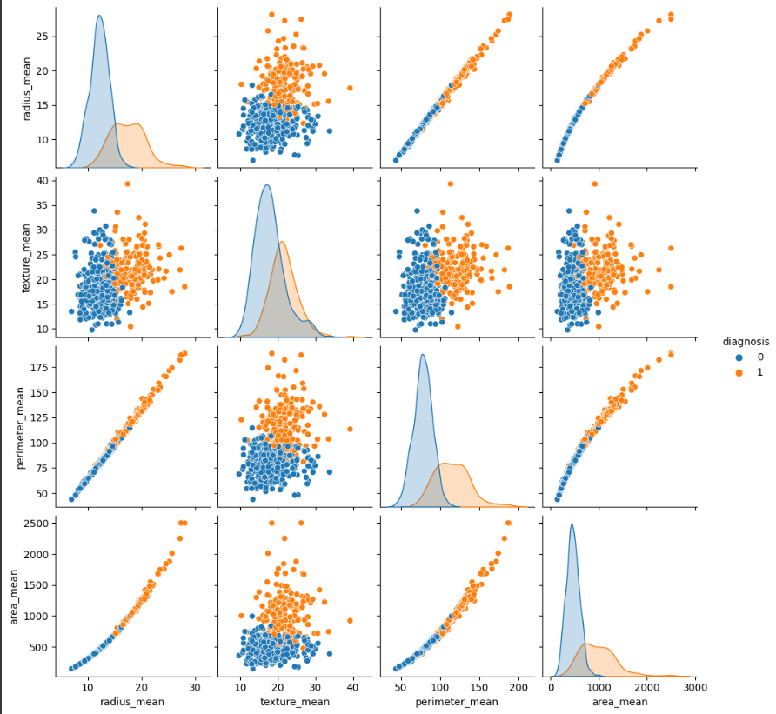
Training model Results
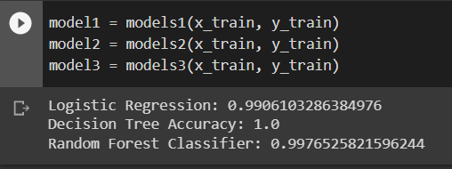

Confusion Matrix of Linear Regression model
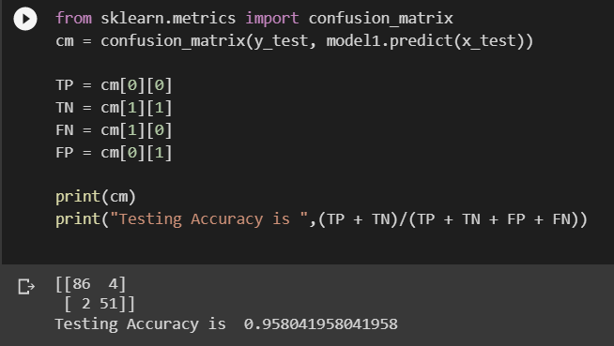

Confusion Matrix of Decision Tree model
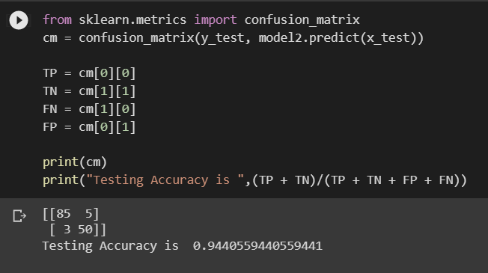

Confusion Matrix of Random Forest Classifier model
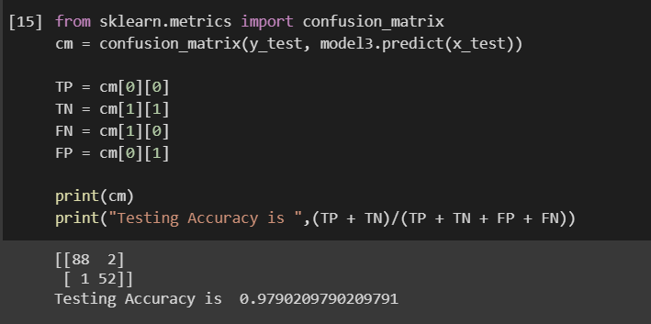

6.2 Application
- Early detection and diagnosis: One of the primary applications of cancer classification AI is in the early detection and diagnosis of cancer. By analyzing medical images or patient data, AI algorithms can identify potential cancerous cells or tumors in their early stages. This can help doctors and healthcare professionals intervene early and increase the chances of successful treatment.
- Personalized treatment: AI can be used to develop personalized treatment plans for cancer patients. By analyzing a patient's medical history, genetic makeup, and other factors, AI algorithms can determine the most effective treatment options for an individual patient. This can improve treatment outcomes and reduce side effects.
- Prognosis and survival prediction: AI can also be used to predict a patient's prognosis and survival rate based on their medical data. This can help doctors make more informed treatment decisions and provide patients and their families with more accurate information about the course of their illness.
- Drug discovery and development: AI can be used to identify potential new drugs for cancer treatment by analyzing large amounts of data from various sources. This can help researchers identify new targets for drug development and speed up the drug discovery process.
- Research and clinical trials: AI can be used to analyze data from clinical trials and research studies to identify patterns and insights that can help improve cancer treatment and care. By analyzing large amounts of data, AI algorithms can help researchers identify potential new treatments, biomarkers, and other factors that could impact cancer care.

7.1 Conclusion
Cancer is a life-threatening disease that affects millions of people around the world. Early detection and accurate diagnosis of cancer are crucial to improve the chances of successful treatment and recovery. However, detecting cancer can be challenging, and it can be very expensive to treat once it has reached an advanced stage. To address this problem, a module has been developed that consists of three algorithms to classify cancer into malignant and benign categories. This will help us identify cancer in its early stages and this algorithm has high accuracy rates, quick responses, and can help patients self-diagnose. This algorithm will save thousands of dollars spent on surgeries and operations of non-cancerous tumors.

Here we have implemented Linear regression algorithm, Decision Tree algorithm, and Random Forest Classifier algorithm. These algorithms are from Machine Learning. These models are optimal for the classification of Cancer as we require a concrete output. This output needs to be a whole number, as we need to classify the cancer into a either malignant or benign outputs. These algorithms can give us output as 0 or 1 for either cancerous and non-cancerous tumours respectively.

The Linear regression algorithm is a statistical method that uses a linear approach to establish a relationship between a dependent variable (cancer type) and one or more independent variables (patient characteristics). It can predict the probability of a particular type of cancer based on various factors such as age, sex, family history, etc. This algorithm uses a mathematical model to identify the features that are most important in determining whether a tumor is malignant or benign.

The Decision Tree algorithm is a popular machine learning algorithm that uses a tree-like structure to classify cancer cells into malignant or benign. It is a simple and effective algorithm that can handle both categorical and numerical data. The algorithm creates a tree-like model of decisions based on patient characteristics such as age, sex, and family history. Each decision node in the tree represents a feature, and each leaf node represents a prediction of cancer type. The algorithm uses a top-down approach to make decisions, and the tree is constructed by recursively splitting the data based on the most significant features.
The Random Forest Classifier algorithm is an extension of the Decision Tree algorithm. It is a powerful algorithm that combines multiple Decision Trees to improve the accuracy and stability of the model. This algorithm uses a random subset of features and data to create multiple Decision Trees. Each tree provides a prediction, and the algorithm selects the most common prediction among all the trees. This approach reduces the risk of overfitting and increases the accuracy of the model.

7.2 Future Scope
The future scope of the cancer classification project is to use image-recognition software to improve the accuracy of cancer diagnosis. This approach will require a much stronger machine to run and a large amount of image data to feed the algorithm in the training sets.
Image-recognition software is a powerful tool that can accurately classify different types of images, including medical images such as X-rays, MRIs, and CT scans. By training the algorithm with a large dataset of cancer images, the software can learn to recognize patterns and features that are unique to different types of cancer, allowing it to accurately classify tumors as malignant or benign.
To implement this approach, we will need to acquire a large dataset of cancer images from different sources, such as hospitals, clinics, and research institutions. This data will need to be properly labeled and organized to ensure that the algorithm can learn to classify tumors accurately.
We will also need to develop a more powerful machine to run the image-recognition software. This could involve using cloud computing resources or investing in high-performance computing equipment to handle the large amounts of data and computational power required for this task.
Overall, the future scope of the project is to continue to improve the accuracy of cancer diagnosis by incorporating advanced technologies such as image-recognition software. By leveraging these tools, we can improve early detection and treatment of cancer, potentially saving thousands of lives and reducing healthcare costs.

- IEEE Xplore, 2022: Active Contour Neural Network Identifying MRI Image Edge Computing Methods Deep Learning Bone Cancer Detection
- Sinthia P and K. Sujatha, “A novel approach to detect the bone cancer using K-means algorithm and edge detection method”, ARPN Journal of Engineering and applied science,11(13), July 2016.
- Kishor Kumar Reddy, Anisha P R, Raju G V S, “A novel approach for detecting the tumor size and bone cancer stage using region growing algorithm”, International Conference on Computational Intelligence and Communication Networks, 2015.
- Maduri Avula, Narasimha Prasad Lakkakula, Murali Prasad raja, “Bone cancer detection from MRI scan imagery using Mean Pixel Intensity, Asia modeling symposium,2014.
- Abdulmuhssin Binhssan, “Enchondroma tumor Detection”, International journal of advanced research in computer and communication Engineering, 4(6), june 2015.
- IEEE Xplore, 2022: Pancreatic Cancer Detection using Machine and Deep Learning Techniques
- Taylor, J., and J. Knight. "Endocrine system 6: pancreas, stomach, small intestine and liver." Nursing Times (2021): 46-50.
- Bagur, Alexandre Triay, et al. "Pancreas MRI segmentation into head, body, and tail enables regional quantitative analysis of heterogeneous disease." medRxiv (2021).
- Garg, Sushil Kumar, and Suresh T. Chari. "Early detection of pancreatic cancer." Current opinion in gastroenterology 36.5 (2020): 456-461.
- Kenner, Barbara, et al. "Artificial Intelligence and Early Detection of Pancreatic Cancer: 2020 Summative Review." Pancreas 50.3 (2021): 251.
- IEEE Xplore, 2020: Lung Cancer Detection Using Deep Learning Network: A Comparative Analysis
- Faridoddin Shariaty, Mojtaba Mousavi, “Application of CAD systems for the automatic detection of lung nodules”, Informatics in Medicine Unlocked Volume 15, 2019, 100173, https://doi.org/10.1016/j.imu.2019.100173..
- Hongsheng Jin, Zongyao Li, Ruofeng Tong, Lanfen Lin, “A Deep 3D Residual CNN for False Positive Reduction in Pulmonary Nodule Detection”, Med Phys. 2018. May; 45(5):2097-2107. doi: 10.1002/mp.12846. Epub 2018 Mar 25..
- Kai-Lung Hua, Che-Hao Hsu, Shintami Chusnul Hidayati, Wen-Huang Cheng, Yu-Jen Chen3, “Computer-aided classification of lung nodules on computed tomography images via deep learning technique”, Onco Targets Ther. 2015 Aug 4;8:2015-22. doi: 10.2147/OTT.S80733. eCollection 2015..
- Shuo Wang, Mu Zhou, Zaiyi Liu, Zhenyu Liu, Dongsheng Gu, Yali Zang, Di Dong, Olivier Gevaert, Jie Tian, “Central focused convolutional neural networks: Developing a data-driven model for lung nodule segmentation”, Medical Image Analysis 40 (2017)172- 183,http://dx.doi.org/10.1016/j.media.2017.06.014.
- IEEE Xplore, 2020: Image Based Fractal Analysis for Detection of Cancer Cells
- "Cancer Facts & Figures 2018," Atlanta, GA: American Cancer Society,2018.
- S. Havlin, S. V. Buldyrev, A. L. Goldberger, R. N. Mantegna, S. M. Ossadnik, C. K. Peng, et al., "Fractals in biology and medicine," Chaos,Solitons & Fractals, vol. 6, pp. 171-201, 1995.
- K. J. Falconer, Fractal Geometry Mathematical Foundations and Applications, 3rd ed. Chichester: Wiley-Blackwell, 2014.
- R. Lopes, and N. Betrouni, "Fractal and multifractal analysis: a review," Medical image analysis, vol. 13, num. 4, pp. 634-649, 2009.

Innovision Project Competition (MIT) 2023:






IdeaGo (MIT) 2023:








TECHNOTHON 2023 National Level Project, Start-up, Paper & Poster Competition (APCOER): 




